Name: __________________________________

Data Collection

Instructions: You have already collected some data from the Northern Wisconsin and Upper Peninsula of Michigan regarding its mineralogy. However, due to bad weather you were not able to finish. Luckily, we have photographs of certain stops that you are to make observations on and analyze.

When taking good field notes, it is important to do the following:
- Sketch the overall structure. Note colors, things you may recognize, irregularities, etc.
- Note everything you see: Grain Size, Grain Roundness, colors, minerals,
- Sketch interesting things. Things like unconformities cross bedding, fractures, oxidation, bedding, intrusions, etc.

For each stop, you will be provided a large scale photo as well as a close up. Be sure to take DETAILED notes of each! Additionally, some stops will have questions to answer

Stop 1: Ship Rock

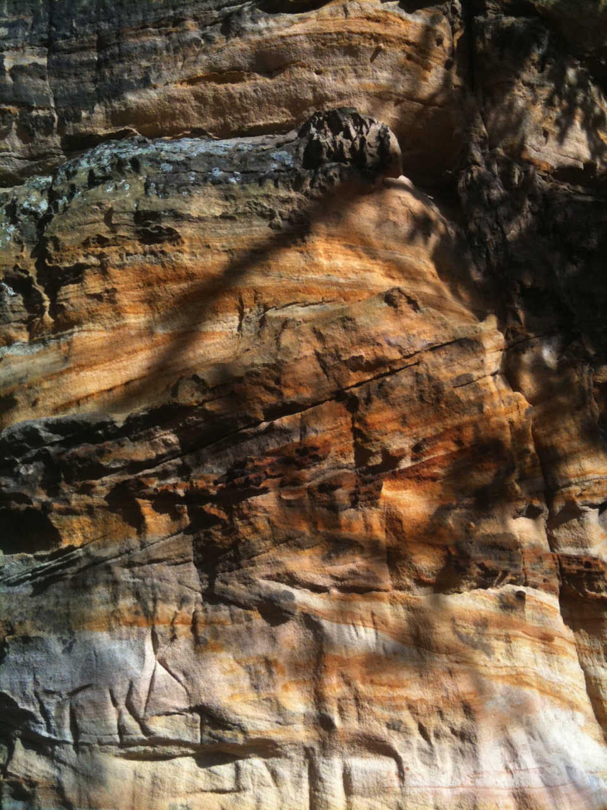
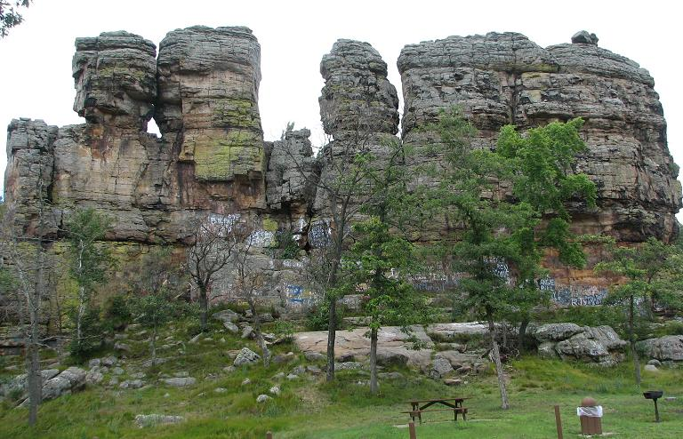

Field Notes:

Stop 3: Powell Kyanite Schist (The structure behind the car)
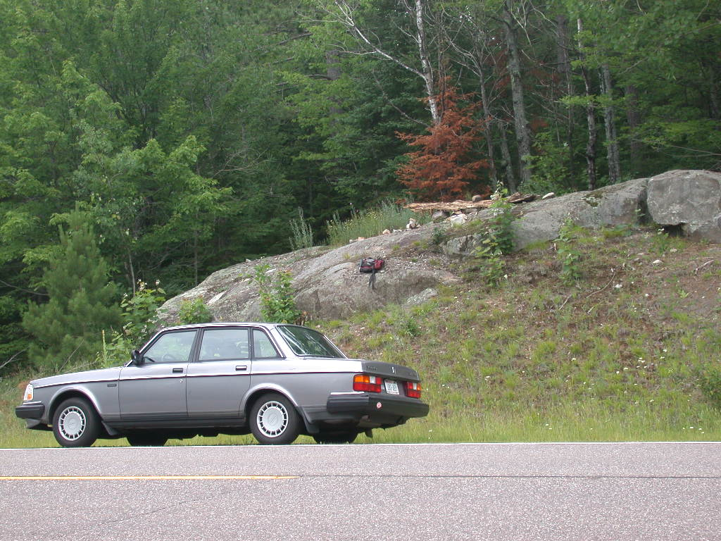

Field Notes:

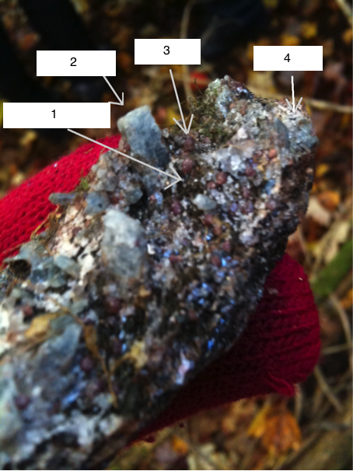
Questions (Regarding Sample)

A. Is this rock sedimentary, igneous, or metamorphic? Explain.

B. Label the different minerals seen in this picture.

1 (flaky, black) -

2 (“deep blue” mineral) -

3 (silicate gemstone, red) -

4 (SiO₂) –

Stop 5: Grus (Rotten Granite) Pits in Ninemile Pluton
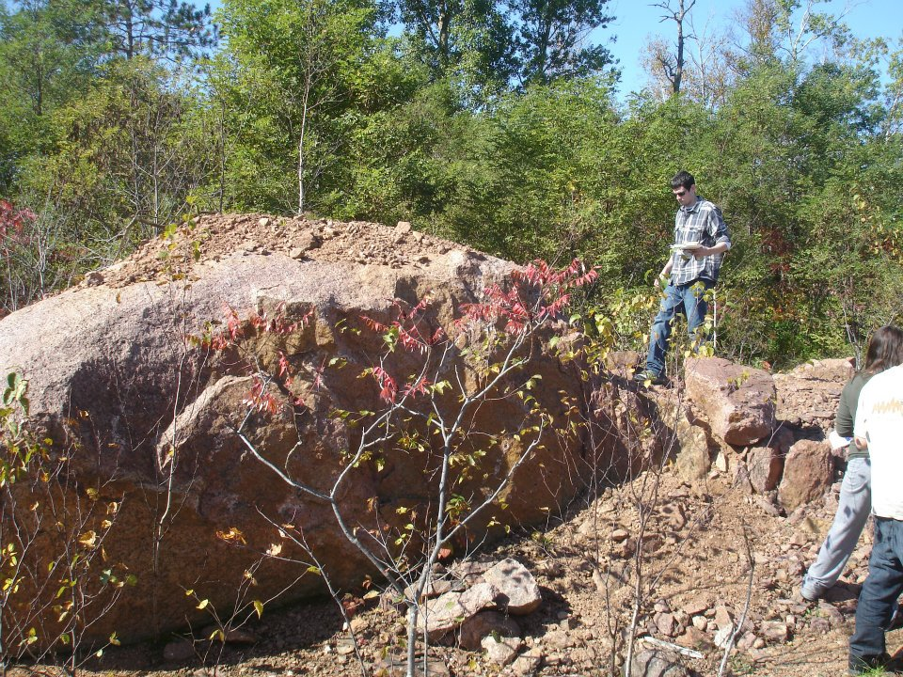

Field Notes:

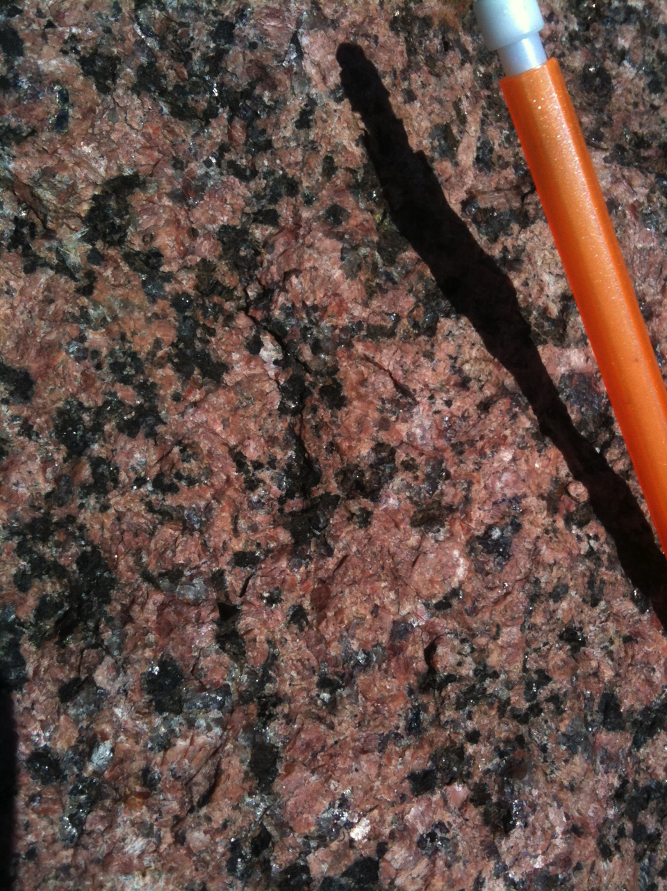

Questions (Regarding Sample)

A. Name the three most common minerals in Granite.

B. Why is this granite so red?

C. There appears to be a lot of gravel here. Would that mean the
Granite is weak or strong? Why?

